**Practical No 2**

**Aim: Study of Use Case Diagram**

**Use Case Diagram** captures the system's functionality and requirements by using actors and use cases. Use Cases model the services, tasks, function that a system needs to perform. Use cases represent high-level functionalities and how a user will handle the system. Use-cases are the core concepts of Unified Modelling language modelling.

A Use Case consists of use cases, persons, or various things that are invoking the features called as actors and the elements that are responsible for implementing the use cases. Use case diagrams capture the dynamic behaviour of a live system. It models how an external entity interacts with the system to make it work. Use case diagrams are responsible for visualizing the external things that interact with the part of the system.

Following are the common notations used in a use case diagram:

**Use-case:**

Use cases are used to represent high-level functionalities and how the user will handle the system. A use case represents a distinct functionality of a system, a component, a package, or a class. It is denoted by an oval shape with the name of a use case written inside the oval shape. The notation of a use case in UML is given below:

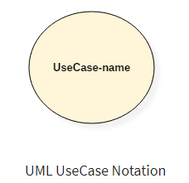

**Actor:**

It is used inside use case diagrams. The actor is an entity that interacts with the system. A user is the best example of an actor. An actor is an entity that initiates the use case from outside the scope of a use case. It can be any element that can trigger an interaction with the use case. One actor can be associated with multiple use cases in the system. The actor notation in UML is given below.

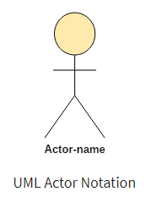

Tips for drawing a use case diagram

1. A use case diagram should be as simple as possible.
2. A use case diagram should be complete.
3. A use case diagram should represent all interactions with the use case.
4. If there are too many use cases or actors, then only the essential use cases should be represented.
5. A use case diagram should describe at least a single module of a system.
6. If the use case diagram is large, then it should be generalized.

**A. Consider the car rental application. The rental agency has multiple offices/locations where customers can test drive and then select a car for rental (location or to outstation). The periods of rental, terms and conditions for rental are flexible. Software has to make responsibility for loaning cars, keeping track of availability of cars, return of cars, billing, maintenance activities for cars and keeping track of driver’s availability and assignment in case of chauffer driven car rentals. Draw use case/s for above application taking advantage of full UML notation for use case diagrams.**

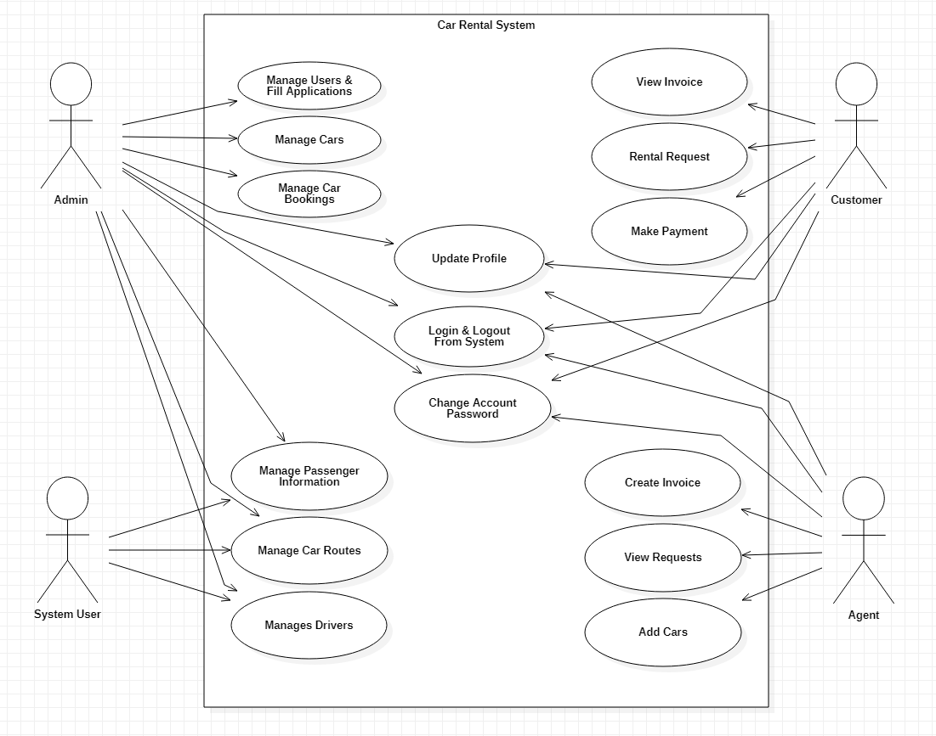

**B. Construct the Use case Diagram for following scenario; student information System. The university conducts many courses and students can register for those Courses. The registrar of the university will introduce any new course. Also, the Registrar maintains the curriculum and student details. The examination will be conducted for the students and the degree is issued for the students who have completed the course successfully.**

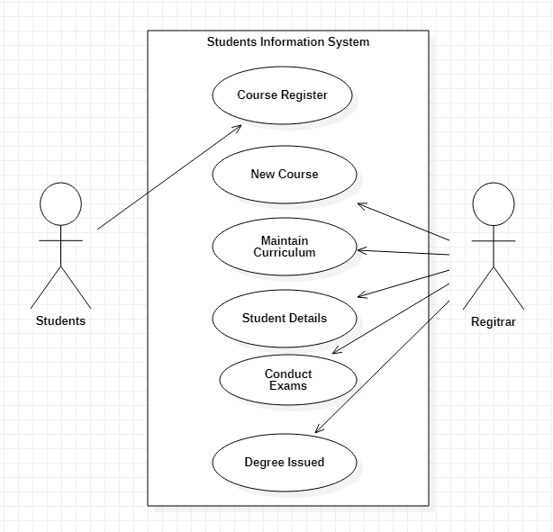

**Conclusion: We have studied the details about the use case diagram.**